HEALTH & SOCIETY ISSUE BRIEF Student Name | S425 | April 21, 2018



Prevention of childhood asthma starts in our homes

Image Source: Here

[choose your own appropriate picture; be sure to credit the source per APA guidelines]

Asthma takes a big toll on children
The title of this section should reflect the health or social problem which is the main focus of your paper. The text here should fill the reader in on what they need to know about the significance, scope and impact of this problem, and identify any groups in society that are disproportionately affected

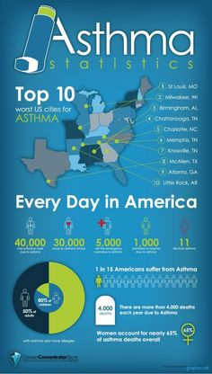
Narrative continues to be developed here.

{assuming you created this] Created by student using data from Wikipedia at www.wikipedia.com

Conditions in the home play a crucial role
Please write a clear and succinct section discussing the related health or social factor (determinant) and describing how the health and social factors are linked.

How do housing conditions impact asthma? [Pathway/ causal chain for bonus points]
[Create a causal chain that graphically represents the connection you wrote about; there are many “SmartArt” Process options you could use, or just insert rectangles and arrows.]

Top Takeaways
Include key facts and main points of your brief.
To create “tiles” of information similar to those used in RWJF example, you may utilize “SmartArt” or just use rectangular shapes as shown below. The size and color can be changed to suit your design.

Key point about housing conditions

Key point about childhood asthma

Key point and/or fact about the link between housing and asthma

Big message: We can do more to reduce the impact of childhood asthma by improving children’s living conditions than by getting them to a doctor.

References

Almeida, J., Kawachi, I., Molnar, B. E., & Subramanian, S. V. (2009). A Multilevel Analysis of Social Ties and Social Cohesion among Latinos and Their Neighborhoods: Results from Chicago. Journal of Urban Health, 86(5), 745–759. https://doi.org/10.1007/s11524-009-9375-2
Anderson, L. M., Scrimshaw, S. C., Fullilove, M. T., & Fielding, J. E. (2003). The Community Guide’s model for linking the social environment to health. American Journal of Preventive Medicine, 24(3, Supplement), 12–20. https://doi.org/10.1016/S0749-3797(02)00652-9
Barten, F., Mitlin, D., Mulholland, C., Hardoy, A., & Stern, R. (2007). Integrated Approaches to Address the Social Determinants of Health for Reducing Health Inequity. Journal of Urban Health, 84(5), 735–735. https://doi.org/10.1007/s11524-007-9209-z
Bernard, P., Charafeddine, R., Frohlich, K. L., Daniel, M., Kestens, Y., & Potvin, L. (2007). Health inequalities and place: A theoretical conception of neighbourhood. Social Science & Medicine, 65(9), 1839–1852. https://doi.org/10.1016/j.socscimed.2007.05.037
Clarke, P., Morenoff, J., Debbink, M., Golberstein, E., Elliott, M. R., & Lantz, P. M. (2014). Cumulative Exposure to Neighborhood Context Consequences for Health Transitions Over the Adult Life Course. Research on Aging, 36(1), 115–142. https://doi.org/10.1177/0164027512470702

